**SDLC - Waterfall vs Agile, Agile, Introduction to DevOps**

**Name : AbdulKhadar & Malik Basha**

**Reviewer : Maheshwara Reddy**

**Contents :-**

**1. Software Development Life Cycle**

1.1 Planning

1.2 Requirements Analysis

1.3 Designing

1.4 Implementation

1.5 Testing

1.6 Deployment

**2. software development methodology**

2.1 Agile Methodology

2.1.1 Why do we need Agile

2.1.2 What is Agile

2.2.3 Values of Agile

2.2.4 Principles of Agil

2.2.5 Advantages of Agile

2.2 Waterfall Methodology

2.2.1 Benefits of waterfall model

2.2.2 Agile vs Waterfall Model

**3. DevOps Introduction**

**1.Software Development Life Cycle :-**

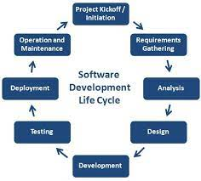

**1.1 Planning** :-

The planning stage is exactly what it sounds like: the phase in which developers will plan for the upcoming project. It helps to define the problem and scope of any existing systems, as well as determine the objectives for their new systems.

**1.2 Requirement Analysis** :-

Requirements analysis, also called requirements engineering, is the process of determining user expectations for a new or modified product. These features, called requirements, must be quantifiable, relevant and detailed. In software engineering, such requirements are often called functional specifications.

**1.3 Designing** :-

The Design Phase is an essential phase of the Software Development Life Cycle. The list of requirements that you develop in the definition phase is used to make design choices. In the design phase, one or more designs are created to achieve the project result.

**1.4 Implementation** :-

Implementation includes user notification, user training, installation of hardware, installation of software onto production computers, and integration of the system into daily work processes.

**1.5 Testing** :-

The testing is done to ensure that the entire application works according to the customer requirements. After testing, the QA and testing team might find some bugs or defects and communicate the same with the developers.

**1.6 Deployment** :-

The work necessary to deploy the final solution into the target production environments. Plus, creating guides for installation, system operations, system administration, and end-user functionality.

**2. Software Development Methodology**

**2.1 Agile Methodology** :-

**2.1.1 Why do we need Agile :-**

We need agile software development because of the following reasons

-Reduce technical maintenance tasks & Minimize risk

-Improve the quality of the product

-Predictable release date

-Improved Customer Satisfaction

-Improved Project Management

**2.1.2 What is Agile :-**

The Agile methodology is a way to manage a project by breaking it up into several stages.

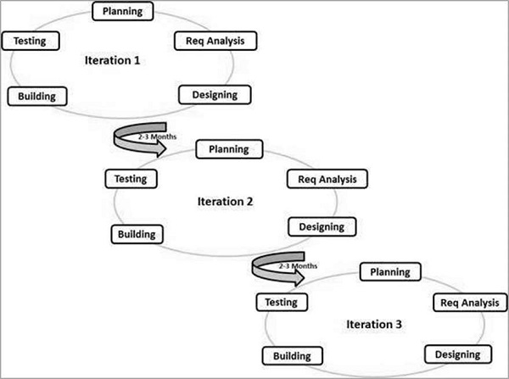

**2.1.3 Values of Agile** :-

-People over process & tools

-Working Software over comprehensive documentation

-Responding to change rather than following a plan

**2.1.4 Principles of Agile** :-

-Satisfy the customer

-Deliver working software frequently

-Maintain constant pace

-Reflect and adjust continuously

**2.1.5 Advantages of Agile :-**

-Persistent software delivery

- Increased stakeholder satisfaction

- Daily interaction

- Increased product quality

**2.2. Waterfall Methodology** :-

Waterfall is a traditional software development method that follows a rigid sequence of steps.

The Waterfall methodology also known as the Waterfall model is a sequential development process that flows like a waterfall through all phases of a project analysis, design, development, and testing, for example, with each phase completely wrapping up before the next phase begins.

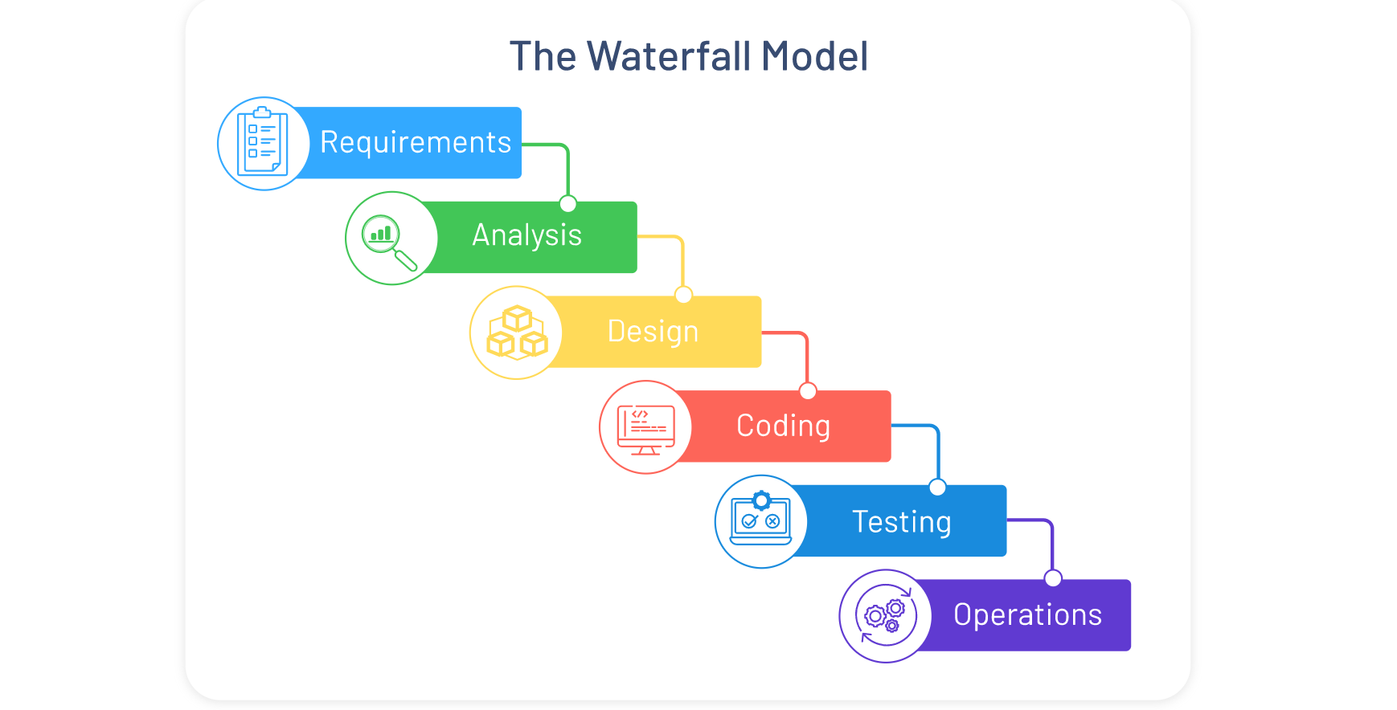

**2.2.1 Benefits of waterfall model** :-

- Easy to manage

- works well for small projects

- Clearly defined stages

- Well documented

**2.2.2 Agile vs Waterfall Model :-**

- Agile has multiple but shorter software development life cycles.

- Waterfall Model has a very longer software development life cycle with fixed phases

- Agile planning is generally done for a very short term since the work product is delivered in 2 to 4 weeks

- WaterFall Model planning done for a long term.

- In agile all of the requirements of the project are not clearly defined they rather develop over the life time of the project

- In the WaterFall Model all of the requirements of the project are clearly defined before the development begins.

**3. DevOps Introduction :-**

The DevOps culture is implemented in several phases with the help of several tools.

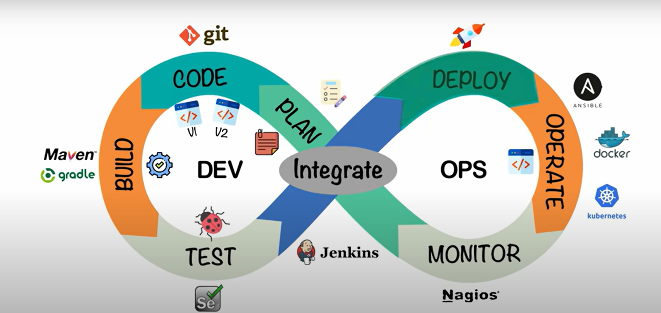

There are many tech giants and organizations that have opted for the devops approach.

Ex - Amazon

- Netflix

- Facebook

- Walmart

DevOps is a combination of software developers DEV and operations OPS. It is defined as a software engineering methodology.